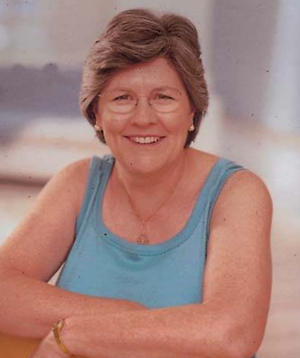
Gillian Fletcher MBE

Gillian Fletcher trained as a physiotherapist in London and returned home to South Africa to work in a Gold Mines Rehabilitation hospital specializing in spinal injuries. Following her return to England in 1971 she gave up work as a physiotherapist to become a full time mother. She has been a National Childbirth Trust (NCT) antenatal teacher since 1972 and a tutor since 1987 and NCT President from 2000-2005. She chaired a multi-disciplinary Maternity Services Liaison Committee (MSLC) and since 1997 to date has run NCT VOICES multidisciplinary workshops for MSLCs across the UK.
She completed her Obstetric Physiotherapy training at the London Hospital in 1975.

She has served on several national committees - RCM, RCOG, NMC,PMETB the NICE, National Collaborating Centre for Women and Children’s Health Board and as a member of the Patient Experience Team affiliated to the National Clinical Governance Support Team (CGST) working on Delivering Healthy Babies and the CGST/ Picker Institute- Patients Accelerating Change projects. With permission from NCT she developed the Voices work across other health fields such as Cancer, Alzheimers, Multiple Sclerosis, Diabetes and Coronary Heart Disease.

In the Research Field:
She had 3 years experience of being a lay member of the Health Technology Assessment (HTA) Population Screening panel and from its inception until 2011 was a lay member of the HTA Consumer Involvement Steering Group.
She facilitated focus groups for two breast cancer research projects in Surrey and currently delivers training on Introduction to Research Methodology workshops at Guy’s Hospital Biomedical Research Centre.
Drawing on her own experience as a trained facilitator and lay representative, her work in Patient and Public Involvement focuses on enabling health service users to be more actively involved in decisions about their care and to work in sustainable effective partnerships with professionals, commissioners and researchers in developing and monitoring health and social care services and health related research..

She was awarded an MBE for services to Healthcare and the National Childbirth Trust in the 2011 New Years Honours List.

Julia Herbert Grad Dip Phys. MSc. MCSP

Consultant Physiotherapist Bladder, Bowel and Pelvic floor dysfunction

Julia has specialised in the treatment and management of pelvic floor muscle dysfunction for over 25 years. Julia currently works in her own private practice and has also developed Consultancy roles with a number of healthcare businesses. She also delivers specialist training to healthcare professionals and lectures both in the UK and Internationally.

Judith Lee

Judith is a Clinical Specialist Physiotherapist at the Nottingham University Hospitals NHS Trust.

Leading the Women’s Health physiotherapy team and is responsible for the service it provides and its development. The weekly routine involves teaching and supervision of the physiotherapy team which includes rotational Band 5 and 6 staff, alongside a personal clinical caseload for pregnancy related musculo skeletal problems, health promotion in the childbearing year, and the management of pelvic floor dysfunction and pelvic pain. Judith regularly teaches Midwives, the Obstetric Medical team and physiotherapy colleagues and leads the 3rd year Physiotherapy student WH module at the Nottingham University.

Having gained full membership of ACPOG (ACPWH now PGOP) in 1991, Judith has been an active member and has represented the organisation for example, at the National Vulvodynia symposium, The World Congress of Obstetrics and Gynaecology, the British Pain society and Royal College of Midwives and has contributed to the Women’s Health chapters in Tidy’s Physiotherapy and Myles Textbook for Midwives. She has been the Trent Area representative, and is a clinical educator for the Bradford post graduate Physiotherapy in Women’s Health course. She was part of the initial working groups for both the “The unique role of the women's health physiotherapist in antenatal care” and “The physiotherapy assessment and management of pregnancy-related musculoskeletal conditions” POGP workshops and continues to be committed to their ongoing development and very much enjoys being a tutor on each.

Mr Gary Ross
Consultant Plastic Reconstructive and Aesthetic Surgeon and Honorary Senior Lecturer University of Manchester
MBChB (University Of Bristol), MD (University of Bristol), FRCS Ed (plast) (Royal College of Surgeons Edinburgh)
Mr Ross performs breast, head and neck and body rejuvenating procedures at the BMI Alexandra and the Christie Clinic in Manchester. By individualising treatments for patients he is able to deliver personalised care from first consultation throughout the patient journey. He focuses on achieving optimal outcomes for patients and has published his own individualised outcomes that are available on his website www.garylross.com
Mr Ross has been working in plastic reconstructive and aesthetic surgery for almost 20 years and as a consultant for the last 7 years. He has published extensively throughout his career and is involved in teaching and education through his role as honorary senior lecturer at the University of Manchester. He is a full member of British Association of Plastic, Reconstructive and Aesthetic Surgeons (BAPRAS); British Association of Head and Neck Oncologists (BAHNO), British Association of Aesthetic Plastic Surgeons (BAAPS), Association of Breast Surgeons (ABS), General Medical Council (GMC) Specialist Register for Plastic Surgery (number 4220633) and has a Certificate of Completion of Training (CCT) in Plastic Surgery.

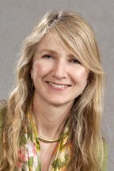
Mandy Fader

Mandy received her nursing qualification from St. George’s Hospital, London in 1980. She began her career in continence with a research post at University College London (UCL) in 1982 and joined the clinical continence team in 1984. In 1995 she returned to research at UCL and worked on a programme of continence product evaluations, completing her PhD in 2001. In 2004 she joined the University of Southampton’s Continence Technology and Skin Health group and leads a team of researchers focusing on research into continence products and devices, and the effects of incontinence on skin health. Mandy is an ex-Trustee of the International Continence Society (ICS), is currently a member of the ICS nurses committee, a committee member for the International Consultation on Incontinence (Management with Products chapter), an editor for the Cochrane Incontinence group, and consulting editor for the US Wound Ostomy and Continence Nursing journal.

Teresa Cook

Teresa is a Women’s Health Physiotherapist with more than 20 years clinical experience in the NHS. She currently works as the lead clinical lecturer on the University of Bradford ‘Continence for Physiotherapists’ programme and as a lay panellist on the Conduct and Competence Committee of the Nursing and Midwifery Council. She also works independently as a consultant and lecturer. She has a particular interest in medico-legal issues and the links between healthcare education and regulation.
Jane Dixon

After qualifying from Manchester Royal Infirmary in 1971, I initially specialised in paediatrics. In 1984 I started in private practice and it was then that I began treating patients with continence problems. In 1996 I completed the ACPWH Post-graduate Continence Course. Since 2002, I have been using real-time ultrasound to assess and treat pelvic floor dysfunction, lecturing natioally and internationally on this topic. I was the co-founder of DUG (the Dynamic Ultrasound Group) which has now merged with ACPIE to form EPADU, the Electro Physical Agents and Dynamic Ultrasound Professional Network.

Jo Laycock OBE PhD FCSP

Jo qualified from the Bradford Hospitals School of Physiotherapy in 1962. Her interest in the management of incontinence developed following an ACPOG course in Leeds in 1978.
Jo is a past chairman and Honorary Life Member of the ACA (Association for Continence Advice), a founder member of CPPC (Chartered Physiotherapists Promoting Continence), a past board member of the ICS (International Continence Society), and has served on several government and CSP committees.

Jo completed her PhD on ‘Assessment and Treatment of Pelvic Floor Dysfunction’ at The University of Bradford, in 1992, and was awarded fellowship of The Chartered Society of Physiotherapy the following year. She received the OBE for ‘Services to Incontinence’ in 2001, and received a ‘Lifetime Achievement Award’ from the ICS in 2011.
Jo has published extensively and has been involved in teaching internationally for many years. She co-edited ‘Therapeutic Management of Incontinence and Pelvic Pain’ with Jeanette Haslam, and together at conference, they will discuss some changes in the assessment and treatment of incontinence during their long careers.
Jo is now retired and lives in The Lake District.

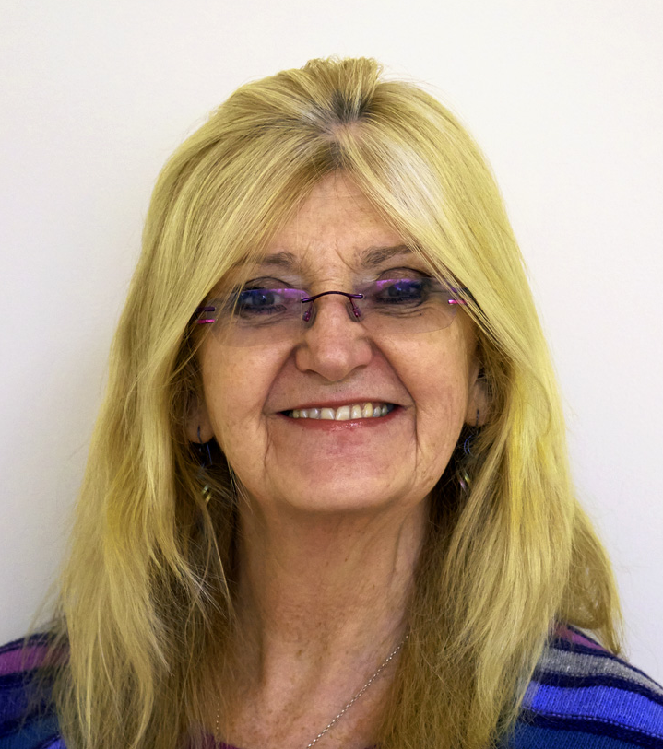
Jeanette Haslam MPhil. MCSP.

Jeanette qualified from Manchester Royal Infirmary School of Physiotherapy in 1971. She first experienced women's health physiotherapy at St Mary's Hospital in Manchester during her student years. As a newly qualified physiotherapist on the Isle of Wight, she found herself responsible for the Maternity and Gynaecology wards and lecturing to the midwives. The die was cast and future determined.
After her 'first retirement' having four children Jeanette returned to physiotherapy at Chorley and South Ribble DGH and over the years developed a Women's Health service for which she won a quality award from the Trust. In 1990 she completed the validated continence course that Jo Laycock had devised. On completion she was a founder member of CPPC of which she was secretary and treasurer for many years. She also became a member, then later chairman of the ACA followed by Honorary Life Membership of that organisation. She was invited to join the education committee of ACPWH later becoming it's chairman. During this time she became involved with the Continence Course being further developed under the auspices of the University of East London, becoming a senior visiting fellow. She was then involved with the setting up and provision of the Masters level continence course with the University of Bradford in 1995.
She completed her M Phil in 1999 on 'Evaluation and assessment of the pelvic floor, digitally, manometrically and by EMG in women', at the University of Manchester, followed by the Bowel continence course at City University, London. After three years living in Germany she returned once more to the education ACPWH committee as Chairman, became a NICE committee member for the urinary incontinence guidelines and on the steering committee of the Leicester Medical Research Council Incontinence study. She has presented at many conferences and was delighted to be the first physiotherapist to win the poster prize at ICS (UK) in 1999. She was also honoured to receive one of the first distinguished service awards from the CSP.
Jeanette co-edited both editions of 'Therapeutic Management of Incontinence and Pelvic Pain’ with Jo Laycock, the second edition of 'Physiotherapy in Obstetrics and Gynaecology' with Jill Mantle and Sue Barton and contributed chapters to many other textbooks and journals. She thoroughly enjoyed her teaching on many courses including ones organised by ACPWH.
Jeanette is now enjoying retirement with many grandchildren and artistic pastimes living in the highest market town in England- Alston, Cumbria.

Claire Rigby

I really enjoyed being a rotational physiotherapist both within the acute and community setting, covering MSK, women’s health, rheumatology and respiratory but in 2010 was ready for new challenge and developed an interest in public health, in particular weight management. I started in a new role as a physiotherapist within the newly commissioned Specialist Weight Management Service (SWMS). I am now the service lead and proudly work within a dynamic team who have pioneered innovative MDT service delivery models, in particular our maternity pathway which is co-delivered by physiotherapists, dietitians and a health improvement midwife.

Jess Bryant

I have worked across a broad range of clinical areas since qualifying as a Physiotherapist in 2003, including working alongside the NHS Institute for Innovation and Improvement for a project in Bolton in 2008. Over the years I developed a special interest in health behaviour change and have worked as a Specialist Weight Management Physiotherapist since May 2010. I have been closely involved in the planning, running and auditing of our separate pathway for pregnant women with a BMI over 35 since its launch in January 2012 and find this client group particularly rewarding to work with, through pregnancy and in the post-natal period too.

Dr Winston F de Mello BSc MBBS FRCA FIMCRCSEd FFPMRCA DRCOP DipPain

Consultant in Pain Medicine University Hospital South Manchester Winston qualified in 1978 from Guy's Hospital and did his Diploma in Pain in the School of Physiotherapy at QMUC, Edinburgh.
He served in the RAMC from 1976 to 1996 and in the Territorial Army until retiring as Colonel TA BATLS in 2013 He leads an MDT clinic for pelvic pain at UHSM for both men and women.

Gill Brook
Women’s Health and Pelvic Floor Physiotherapist, Bradford Teaching Hospitals NHS Foundation Trust

Gill has specialised in women's health and pelvic floor physiotherapy for 27 years and currently works for the NHS in Bradford, and in private practice in Ilkley and Horsforth, West Yorkshire. In addition, she is a tutor for Pelvic Obstetric & Gynaecology Physiotherapy and for the University of Bradford on their postgraduate certificate, Physiotherapy in Women's Health. Gill has taught and lectured nationally and internationally, and authored book chapters and papers in peer reviewed journals. She has held several executive committee positions with ACPWH in the past, including a term of office as chair. Since 1999 she had been an executive committee member of the International Organization of Physical Therapists in Women's Health (IOPTWH), a subgroup of the World Confederation for Physical Therapy (WCPT) and is the current honorary secretary. Gill has a particular interest in the establishment and support of women's health physiotherapy services in developing countries. She supports the physiotherapy team at the Hamlin Fistula Hospital, Addis Ababa, Ethiopia who she visits annually. She is currently a member of the Fistula Committee of the International Continence Society.

