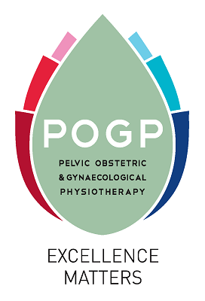

**Criteria for Full membership of POGP**

As a professional organisation, POGP supports registered physiotherapists working in the specialty of pelvic health, obstetrics and gynaecology providing good practice advice; mentorship and educational opportunities. Membership eligibility is provided by three routes to promote excellence and quality in this specialist area of physiotherapy.

The candidate must provide evidence of physiotherapy experience in one or more of the specialty areas of male and female bladder, bowel and sexual dysfunction and pain; pre- and post-natal musculoskeletal dysfunction and pain; breast care, oncology.

Membership routes:

1. **Completion of a POGP recognised post-graduate course (PG certificate)**

Demonstrate successful completion of one of the POGP-endorsed post-graduate courses at Bradford University – Physiotherapy for Women’s Health or Continence for Physiotherapists both worth 60 credits – or the Brunel University Advanced Clinical Practice (Pelvic Health) programme. *(Please note, the aforenamed courses at Bradford University are currently on hold during a review process. March 2024.)*

A short personal statement should be included to demonstrate how you have developed your skills in assessment and patient management in the specialty of pelvic, obstetric, and

gynaecological physiotherapy (500 words) accompanied by evidence of completion of the course (title of course and date attended) and your HCPC registration number.

International physiotherapists who do not reside or work in the UK and are not registered with HCPC in the United Kingdom, may still apply for Full membership (Full International category) but must have proof of membership to their own country’s recognized physiotherapy governing body.

1. **An academic award at Master’s or PhD level in a relevant topic area**

Demonstrate successful completion of a Master’s or PhD in a relevant topic area (as above).

A short personal statement should be included to demonstrate how you have developed your skills in assessment and patient management in the specialty of pelvic, obstetric and gynaecological physiotherapy (500 words) accompanied by evidence of completion of the degree and the HCPC registration number. International physiotherapists who do not reside or work in the UK and are not registered with HCPC may still apply for Full membership (Full International category) but must have proof of membership to their own country’s recognized physiotherapy governing body.

1. **Portfolio of Evidence**

Submission of a portfolio of evidence of practice ([*see Portfolio of Evidence SOP*](https://thepogp.co.uk/progression_to_full_pogp_membership.aspx)*).*

International physiotherapists who do not reside or work in the UK and are not registered with HCPC may still apply for Full membership (Full International category) but must have proof of membership to their own country’s recognized physiotherapy governing body.

For queries and further information please contact [info@thepogp.co.uk](mailto:info@thepogp.co.uk).