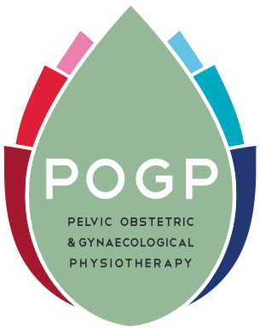

AGENDA
Annual General Meeting of Pelvic, Obstetric & Gynaecological Physiotherapy
Friday 9th October 2020
Virtual meeting on Zoom

- Apologies for absence

- Minutes of 2018 AGM (there was no AGM held in 2019 due to new charitable status)

- Adoption of Annual report

- Treasurer’s Report and adoption of annual accounts

- Appointment of a financially qualified person

- Agreement of annual membership subscriptions to remain unchanged in 2020

- Chairman’s address

- Election to board of trustee positions

- Questions

- Date and venue of 20121 conference and AGM

