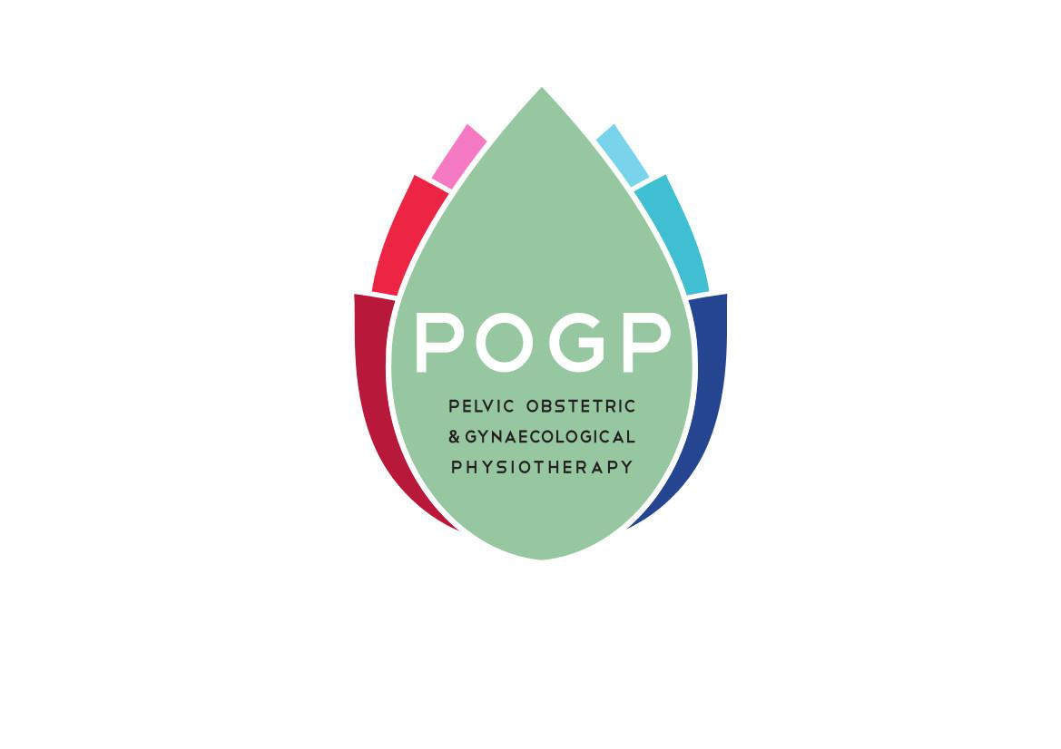

POGP COPYRIGHT GUIDANCE

POGP publications are written by experts for POGP involving significant provision of time and resource including commissioned illustrations. The publications are reviewed and updated regularly to remain current.

POGP owns the copyright of the Mitchell Method of Physiological Relaxation.

Business use of the POGP logo is available to full members of POGP. Other permitted use of the logo will be by request.

POGP are keen to make these resources available to members for the purposes of education and training. This document provides guidance on the copyright and intellectual property rights considerations that will be applied following requests for the use in part or whole of any POGP publication or logo.

In general, copy requested for an individual’s own use for educational purposes (journal/academic use), or for the education of other healthcare professionals is likely to be approved subject to content.

Permission is not required for use of POGP website links used within other healthcare documentation to specific booklets or information sections.

How to apply for copyright permission:

- Requests should be made using the permission form (Use of POGP publications – POGP Copyright Permission Request | POGP (thepogp.co.uk)) found on the website in the copyright guidance section or by email and sent to info@pogp.co.uk FAO the POGP Publications Officer

Please note:
If permission is not sought in this way, it will be considered a breach of copyright.

- A response will be provided as soon as possible and confirmed in writing with conditions of the permission specified. A copy of the signed permission form agreement should be returned to POGP

Copyright permission is usually granted for the following
requests;

  - a single illustration for a single purpose and permission is not transferable

  - for short sections of any public information leaflet or academic publication to be reproduced which may include data or related image. Permission for a larger percentage may be granted and the decision will be made per individual request.

  - Use of POGP Logo.
This is likely to be granted for educational purposes
and approved promotional material.

Copyright permission is not granted for the following
Requests:

- Any copy for use on websites

- Any copy for use on presentations for commercial use

- Any copy requested for commercial production and use within NHS or private healthcare literature

Where copyright has been granted the following must be applied:

1. Where permission is granted all copy must be
accredited: “Reproduced with permission of Pelvic Obstetric and Gynaecological Physiotherapy”( thepogp.co.uk ).

2.Where permission is granted for the use of an image from a POGP booklet – the copyright mark of the artist must be retained.

3.Use of all POGP logos is dependent on the quality of reproduction and as such should adhere to colour control. This will be supplied on granting of copyright permissions.

4 Illustrations must not be amended/altered or re-labelled in any way

5.References in the text will use the following acknowledgement, amendment subject to the referencing style required for publication:
Title of booklet/ publication, Author, Copyright, Year, POGP

Title of article, Author, Journal, Title, Volume, Issue, Year, POGP

For Images/Photographs:
Title of image, Source publication, POGP, Year

6.Where more than one publication is referenced in one
citation then each publication should be separately
referenced

- In the case of textbooks, the editors should ensure that permission is granted for the use of text or diagrams which belong to POGP and acknowledged as described above.

