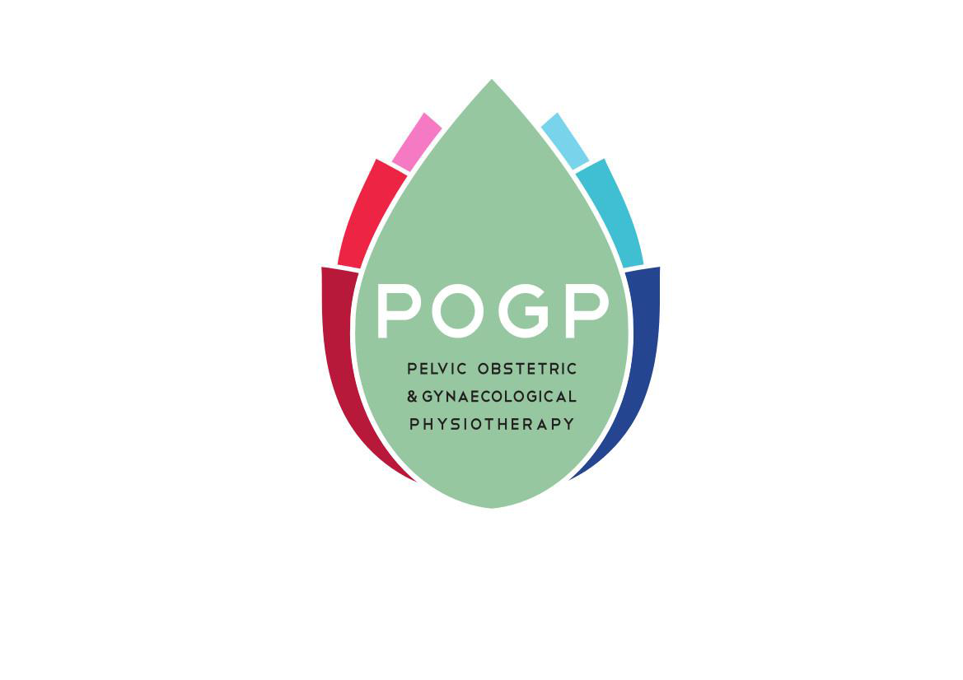

Excellence Matters

The Pelvic, Obstetric and Gynecological Physiotherapy
Social Media Code of Practice

The Chartered Society of Physiotherapy document ‘Social Media Guidance for CSP members’ published in November 2014 is available for CSP members to download as a PDF.

http://www.csp.org.uk/publications/social-media-guidance-csp-members

Its purpose is to encourage members to embrace social media in a ‘productive, safe and professional manner.’ It is aimed at the beginner or the novice user who wishes to develop their social media activity but it also provides some guidance on professional issues for those members who are more established users. The guidance suggests that any physiotherapists working in a team or organisation should consider producing a Social media code which will provide the group with a framework to ‘act consistently and to remain professional’.
This document is a Social Media code of Practice for POGP members.

The POGP Social Media Accounts

1.The POGP iCSP network
http://www.csp.org.uk/icsp/womens-health
This is part of the Interactive CSP which is found on the CSP website (www.csp.org.uk) and is available to CSP members only. Appointed POGP members moderate the site and there are strict community rules that must be adhered to at all times
http://www.csp.org.uk/help/community-rules

2. The POGP Twitter Account
POGP (@ThePOGP) | Twitter https://twitter.com/thepogp
Posting comments or articles on the POGP twitter account is the responsibility of the executive committee. Members are encouraged to follow the POGP twitter account. Any comments or messages to POGP must follow the social media code for POGP members

3. POGP on Facebook

The group is known as ‘POGP Members Area’ and it is a closed page only available to POGP members. It provides a platform for group discussion and exchange of ideas in a secure environment. If a member lapses on membership subscription or chooses to leave POGP access to the POGP Facebook page will be denied.

The link is

https://www.facebook.com/groups/1652693234997631/

Social Media Code of Practice for POGP members

POGP encourage the use social media and asks that the following guidelines should be considered when posting content with any reference to POGP.
- POGP requests that any personal account name does not use the letters POGP or the POGP logo although you may promote your membership of the organisation in your social media biography

- Members should not follow individuals or organisations on behalf of POGP unless expressly asked to do so by the chairman of POGP

Professional Conduct
- The HCPC states that when members are using social media they to do so within the relevant Standards of Conduct, Performance and Ethics.
http://www.hpc-uk.org/aboutregistration/standards/standardsofconductperformanceandethics/
- POGP as a recognised PN of the CSP is bound by the CSP’s Code of Professional Values and Behaviours and therefore this applies to all members of POGP, both CSP and overseas members.
http://www.csp.org.uk/professional-union/professionalism/csp-expectations-members/code-professional-values-behaviour
- Members should act in a professional manner and use sound judgement before posting showing proper consideration for other people’s privacy and being respectful of individual’s opinions
- It is advisable that your biography is regularly updated in any social media account
- Posts should be accurate, factually correct and capable of substantiation. If something is posted in error, it should be acknowledge and corrected as soon as possible whilst referencing the correction against the previous posting.
- Members must maintain professional boundaries and must NOT follow individuals or organisations on behalf of POGP
- Members must not communicate or refer to patients on any social media site
- Poor professional conduct can negatively affect not only an individual but any organisation associated with the individual
Personal Conduct
- Never post inflammatory comments or tweets which could be interpreted as being deliberately malicious, misleading or unfair about other organisations, individuals professional network or colleagues
- Do not post obscene, defamatory, threatening or discriminatory comments about? An individual, organisation or entity (see legal and regulatory)
- If you respond to comments on a social media platform that you consider unfair or incorrect always remain polite, professional and accurate.
- Posting anonymously may attract negative accusations that you have ulterior motives e.g. for personal or business gain
Legal and Regulatory Considerations
- Respect other people’s intellectual property including trade marked names, slogans and copyrighted material.
- Make sure that permission to post copyright items has been granted and reference the work to the owner of the copyright. If you are unsure of the owner of the content you wish to post DO NOT POST the content
- Racist, sexist, homophobic comments, harassment or bullying through social media is against the law
Privacy, Confidentiality and Disclosure
- Remember you are bound by the Data Protection Act 1988, which regulates the information about living individuals. This is particularly important in relation to posting anything in relation to patients or clients.
- Assume that anything you say can be read by anyone, anywhere, at any time and will always be available to be seen even once deleted
- Only reference information that is publicly available. Or where there is evidence that the author of a work has given permission
- Defamation takes place if the content posted harms the reputation of an individual or organisation. Take great care with discussions on social media. Comments deemed to be libellous could result in a defamation case against you personally.
Members must be mindful of any policies, which will be in place for the use of Social media in their own workplace

